9/9 - Questions for tomorrow meeting

Expecting 2 more circuit boards?

2x IWR6843 AOPEVMs - **Radar Device**

mmwaveICboost - **Used for software development,** can work with the SDK using this board. But it also must be connected to the radar.

DCA1000 needs barrel connector

Radar gets powered from USB

DCA1000 - more for raw data capture, not needed for software development.

-Useful for collecting machine learning data

OOB demo - may work with just radar

Mouse position be a different subsystem then the gestures.

Sensing estimator is a more appropriate tool to instantly visualize it

Once you have something good using sensing estimator, definitely be having to tweak the chirp settings and retraining the model.

For starting out, the sensing estimator is the best.

Studio - Don’t know how useful it would be, in beginning at least

Once we have a good chirp configuration, can start using the DCA1000

“Always be tweaked, constant thing”

My ConOps:

-Finding Optimal Chirp Configuration

-Lot of work in the beginning of the project, but once good one is found we may need to tweak it, but not a whole lot to it. Maybe I could also devote time to training models?

Stravros said that what we had already should be good for 403

DCA1000 sends raw binary

**-Find optimal chirp configuration and send raw binary data that is collected to the computer?**

-DCA1000 communicates, but I may have to worry about putting it all into a usable format.

To Do:

-Order power brick?

-Resource explorer on Radar Academy

DCA1000EVM not used with the IC boost. Connects to the radar and the computer. Sends raw binary data from the ADC to the computer. Can do post processing

~~For my understanding:~~

~~Two components  
 -DCA1000EVM~~

~~-~~**~~Capture card~~**~~, “allows users to capture the raw ADC data over the high-speed debug interface and post process it into the PC”~~

~~-’MMWAVEICBOOST’~~

~~-~~**~~Radar.~~** ~~Does it send the data to the capture card, then from the capture card to the PC?~~

* What is the device (Radar unit) called? (vague- ‘MMWAVEICBOOST’)
* MMWAVEICBOOST says it can receive power via the microUSB. **What about the capture card? Do we need a barrel connector for this?** **Or will the bridge connector between capture card and mmwaveICboost power it?**
* **Get a power block for it**
* Do I need to switch to DCA1000 mode?
* Yes, for data collection for Daniel to use. OOB demo use standard switch setting
* 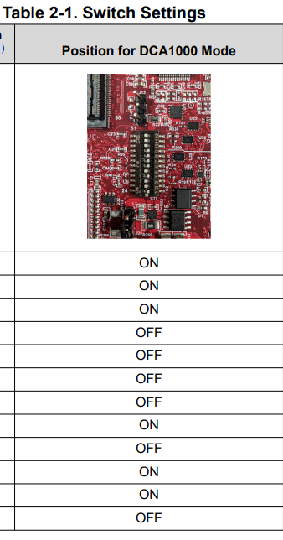

How to make it run on my laptop?

* Out of Box Demo? -<https://dev.ti.com/tirex/explore/node?node=A__ACG08uvVuwpX-4E74miWtw__radar_toolbox__1AslXXD__LATEST>
* Need 2x 5V 2.5A 2.1mm barrel connectors?
* Review subsystem summary for **CONOPS**
* **I/O for each subsystem?** (how does the radar device send data to Daniel to process etc…)

Top -radar

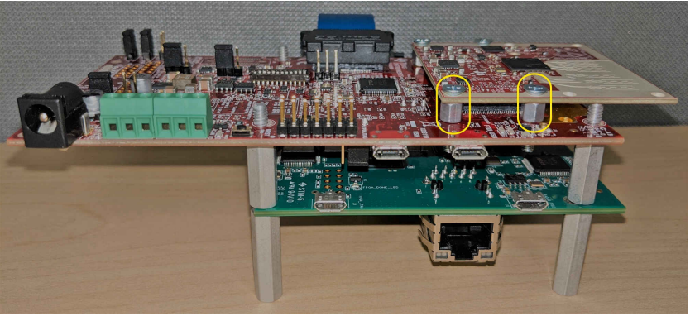

Documents

—----------------------------------------------------------------------------------------------------------------------------

9/18 Meeting

Problem:

Cannot get the individual radar to do TI out-of-box demo (data port will not connect)...

Technical merit?

-Chirp configuration and data format?

-Garrett: Perhaps I can write some code that will modify the chirp signal depending on distance to the hand and resolution (person presenting away from the computer)

-Nick thinks this is a great idea

-The way that you change the chirp on the device is just by generating a configuration file (.cfg file) and then loading that onto the device.

-Sounds not straightforward, but a good idea to increase technical merit (like changing the chirps in real-time depending on range)

-Could be a GUI for the project? If I am interested in making a GUI to change settings or “turn on the program”:

Other radar team: iWR6432 (probably harder to work with than ours)

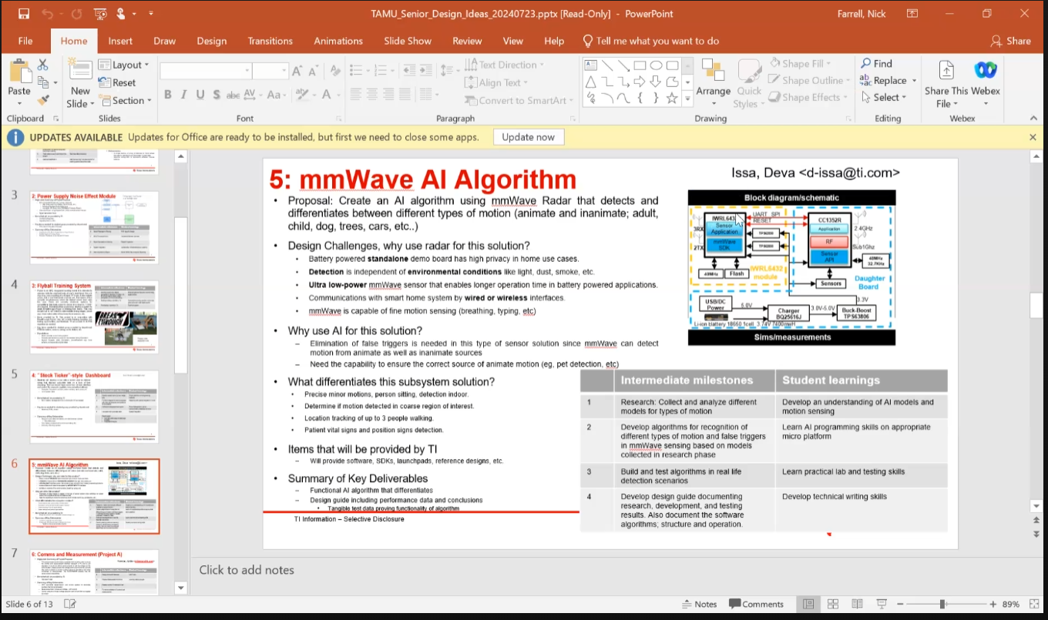

Looking at E2E, we have to write binary files? ←Ignore

o **Build an app that says “hello world” on the microprocessor instead of using TI’s code**

§ **This shows tools are configure and works**